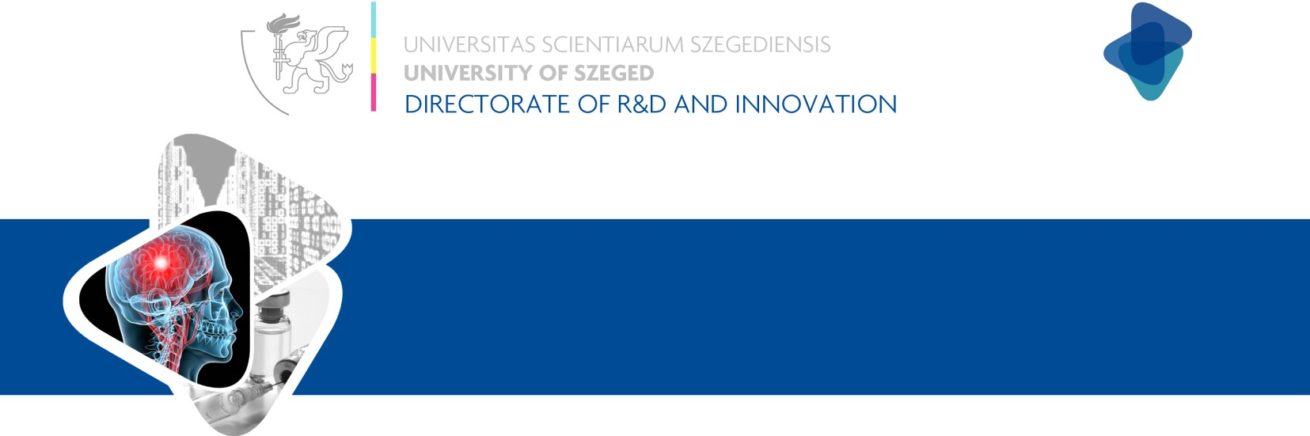

TECHNOLOGY INFO SHEET

Method and diagnostic kit for diagnosing susceptibility of post-traumatic scar tissue formation

Development status | IP status
Proof of concept | In priority year
Development | PCT I.
Product development and Testing | PCT II.
Entering to market | National/regional phase
Market development | Grated patent: HU

Challenge

In some cases of endotracheal intubation benign airway stenosis can evolve. Respiration problems can cause nascent scar tissue, which must be eliminated by operation. We cannot forecast the post-traumatic scar tissue formation now, but our invention could resolve this problem.

Technology

The invention is a PCR-based method and a diagnostic kit for diagnosing post-traumatic scar tissue formation with the TGF-β1 gene-specific sequence. If the patient carries the homozygotic wild type allele of this gene, then the patient is considered to be susceptible to post-traumatic scar tissue formation.
The present invention is based on the surprising and unexpected finding that the ratio of the C/C genotype of -509 C/T TGF-β1 polymorphisms is higher among patients with post-traumatic tracheal scar tissue. Therefore, the determination of this polymorphism offers a good possibility to forecast susceptibility to the development of post-traumatic tracheal scar tissue.

Keywords
PCR-based diagnosing, diagnostic kit, tracheal stenosis, post-traumatic scar tissue forecast

Benefits
Early stage diagnosis of post-traumatic tracheal scar tissue.
Patient-friendly method.
Opportunity for prophylaxis.
Easy and simple way to diagnose accurately. Economical.

Development status

The research phase has been successfully finished. Next step is to enter the product development phase.

IP status

The Hungarian patent was granted in 2012 (Patent no.: 227658) for the PCR-based diagnostic method and diagnostic kit for diagnosing post-traumatic scar tissue formation.

What we are looking for
The university would like to sell or license out the invention. The university is seeking companies who are interested in developing diagnostic kits. The anticipated task of the licensee is to further develop the invention into a diagnostic kit. The university is open to negotiate utilization forms, such as partnering and cooperation in the development.


Contact
Dr. Dániel Madarász

Office Manager
Knowledge and Technology Transfer Office
Directorate for Innovation
E-mail: daniel.madarasz@szte.hu
Tel: (+36-62) 546-702

